Author: Ndiouga Benga
Samb, Issa (b. 1945 Dakar, Senegal-)
Born in Dakar, Senegal, Issa Samb is a sculptor, a painter, an actor, a performance artist, a philosopher, a writer and a critic who is also known as Joe Ouakam or Joe Ramangelissa Ouakam. He studied art at Institut National des Arts and philosophy and law at Université de Dakar in the late 1960s. Very early, he developed a liking for understanding the meaning of symbols. In 1974 he founded, with a group of artists (El Hadj Moussa Babacar Sy, known as El Sy, Guibril André Diop, Bouna Séye), filmmakers (Djibril Diop Mambety), writers (Theirno Saïdou Sall), the Laboratoire Agit’Art. The aim of the Laboratoire was to transform the nature of artistic practice from a formalist, object-bound sensibility to practices based on experimentation and agitation, process rather than product, ephemerality rather than permanence. With a focus on the unexpected aspect of actions, Laboratoire Agit’Art was characterised by its critical stance towards institutional power, of the Negritude’s ideology and the Senghorian field of cultural production, such as the École de Dakar’s painters. Issa Samb is a symbolic figure and patron of art in Senegal.
Issa Samb lives in Dakar within his home-atelier, which combines all sorts of objects: a permanent exhibition that varies on a daily basis, using trash, other recycling material and found objects such as chiffons, bottles, caps, cans and metal parts, questioning accepted notions of fine arts as durable, immortal objects separated from life. Issa Samb insists in the fact that the objects have no existence except in relation to their environment. The process of creation is more important than the finished product. “When I make a piece, […] I have total freedom to do creative work. Therefore, others have total freedom to say, think or give their own interpretation. I forbid myself all forms of prohibitions, background stories, explanations, interrogations. Samb makes frequent references to political figures and social issues of postcolonial Africa, using practices of collage and assemblage. He has never sought to be exhibited, preferring to show his work in his home for more than forty years to escape the conformism of exhibition spaces. He co-founded the Galerie Tenq – Village des Arts. He is the author of numerous plays, poems and essays. A retrospective of his work was held at the National Gallery, Dakar in 2010. His work has been included in exhibitions such as dOCUMENTA (13), Kassel, 2012, Biennale de l’Art Africain Contemporain, Dak’Art, 2008 and 2012 and “Seven Stories of Modern Art in Africa”, Whitechapel Gallery, London, 1995.

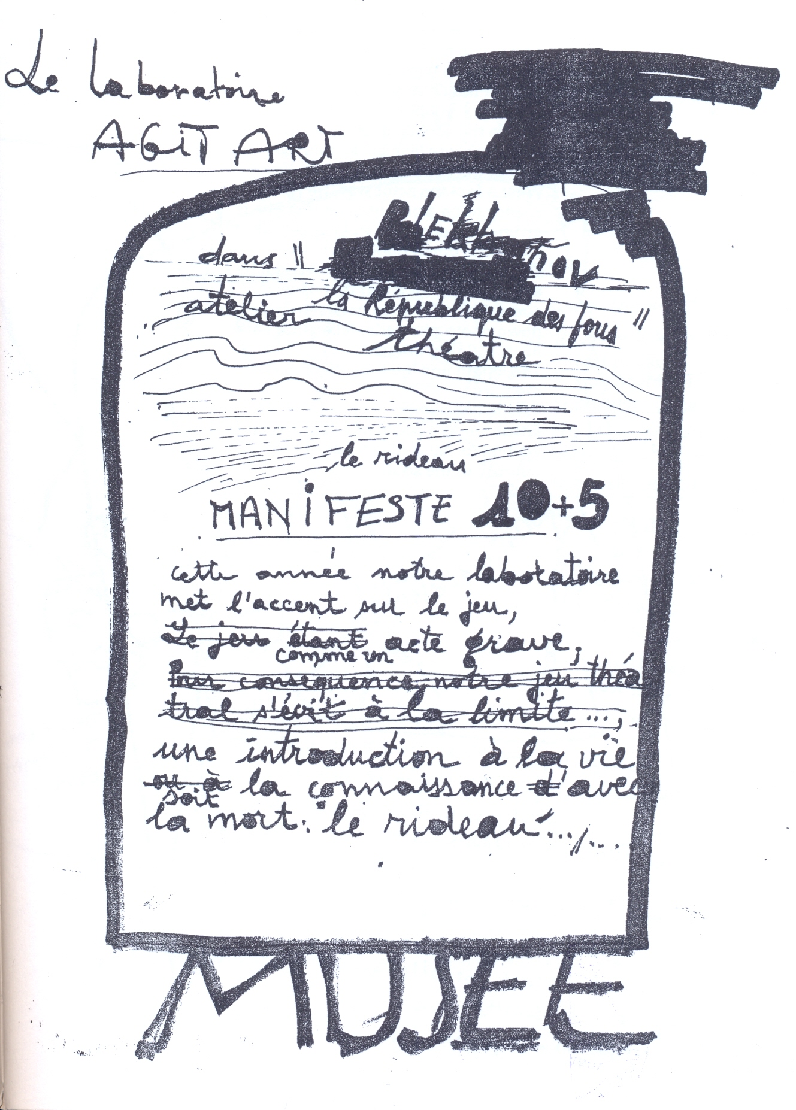

Issa Samb, Laboratoire Agit’Art : Plekhanov in the Republique of Madmen (workshop theatre) in Kouoh, K. (ed.) (2013) Word ! Word ? Word ! Issa Samb and the Undecipherable Form. Parole ! Parole ? Parole ! Issa Samb et la forme indéchiffrable, Office for Contemporary Art Norway Oslo, Raw Material Company Dakar, Berlin: Sternberg Press, p. 331.
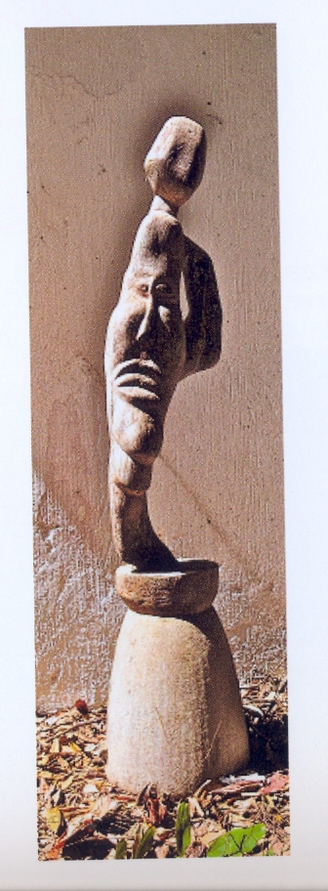
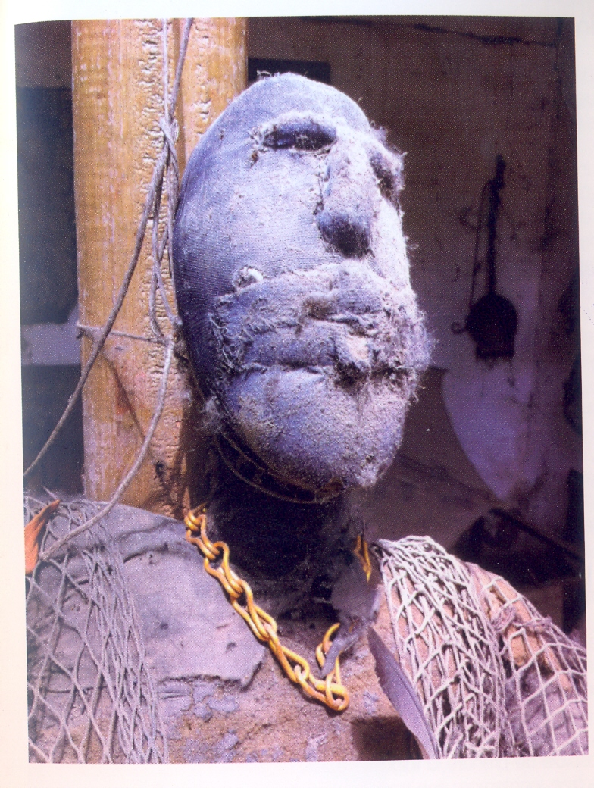
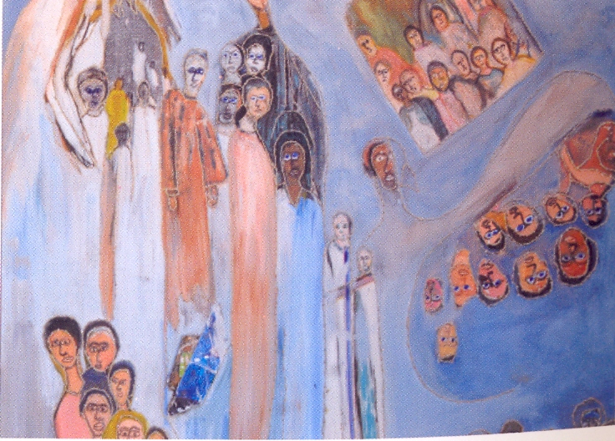

Some works of Issa Samb in Dixième Biennale de l’Art Africain Contemporain, Dak’Art 2012, Tribute to Joe Ouakam, www.biennaledakar.org/2012.

Selected list of works
- Filmography
- 2010 : Lumière sur Ndar. Portrait du Père Jean Vast (1921-2005), by Mansour Kébé (Image et Vie).
- 2001 : La Double Lumière, by Jean Michel Bruyère (Vidéo. 54mn, colours. Coproduction ZKM, CICV, Epidemic, LFK-lafabriks)
- 2000 : Les 4 Trous du langage, by Jean Michel Bruyère (Vidéo. 60 mn, B&W and colours. DVcam. Coproduction CICV, LFK-lafabriks).
- 1999 : La fête silencieuse, by Jean Michel Bruyère (Vidéo. 26mn, B&W. DV. Coproduction CICV, LFK-lafabriks, Laboratoire Agit’Art).
- 1999 : Elements of a Naked Chaise, by Jean Michel Bruyère (35 mm, 57mn, B&W and colours. Coproduction CICV, LFK-lafabriks)
- 1995 : Impressions, by Jean Michel Bruyère (Vidéo. 15mn, colours. Hi8 Production FDM©dropper).
- 1992 : Hyènes, by Djibril Diop Mambéty (Screenplay, 110 minutes. Senegal, France, Suisse, Cinémathèque Afrique (Cultures France)/ADR Productions/MK2 Diffusion/Cinéart-Cinélibre/Thelma Film AG/Maag Daan Film & TV/California Newsreel)
- 1990 : An Alé, Toto Bissainthe (Collectif 2004, Images KS Visions)
- Books
- 2004 : Poto-Poto Blues, Dakar: Les Editions Feu de Brousse.
- 2009 : Les criquets (Théâtre), Dakar: Les Editions Feu de Brousse.

References and further reading
Dixième Biennale de l’Art Africain Contemporain, Dak’Art 2012, www.biennaledakar.org/2012
Harney, E. (2004) In Senghor’s Shadow. Art, Politics and the Avant-Garde in Senegal, 1960-1995, Durham: Duke University Press.
Kouoh, K. (ed.) (2013) Word ! Word ? Word ! Issa Samb and the Undecipherable Form. Parole ! Parole ? Parole ! Issa Samb et la forme indéchiffrable, Office for Contemporary Art Norway Oslo, Raw Material Company Dakar, Berlin: Sternberg Press.

